|  |  |
| --- | --- |
| Course Name | ITD 2313 – Script Programming |
| Instructor | Put instruction name here |
| Student Name | Put student name here |
| Due date | Put assignment due date here |
| Grade | Put grade earned here |
| Grading Comments | Put instructor comments here |

2. You can calculate the surface area of a cube if you know the length of an edge. Write a program that takes the length of an edge (an integer) as input and prints the cube’s surface area as output

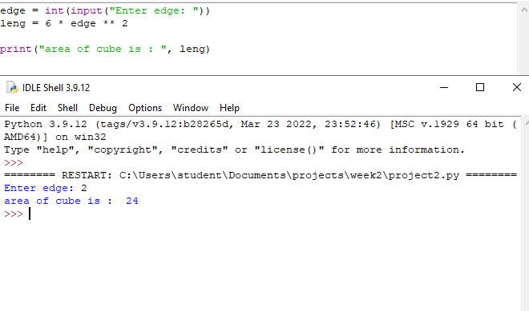

1. Five Star Retro Video rents VHS tapes and DVDs to the same connoisseurs who like to buy LP record albums. The store rents new videos for $3.00 a night, and oldies for $2.00 a night. Write a program that the clerks at Five Star Retro Video can use to calculate the total charge for a customer’s video rentals. The program should prompt the user for the number of each type of video and output the total cost.

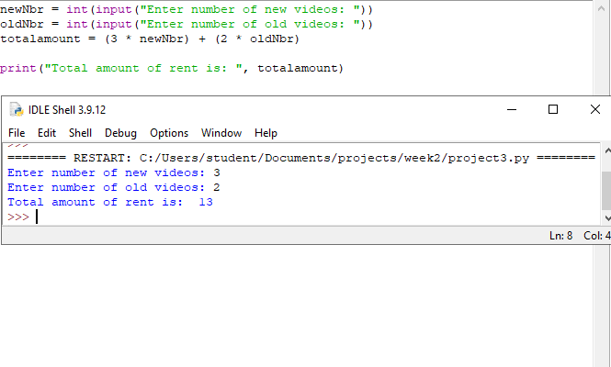

1. Write a program that takes the radius of a sphere (a floating-point number) as input and then outputs the sphere’s diameter, circumference, surface area, and volume.

